GEM (Genealogy Extensible Markup)

Proposed Data Structure Models

Ancestry of an individual was chosen as the fundamental data structure. Each person <per> (together with their full siblings) is the product of a family tree with two parents, four grandparents, etc., (known or unknown). The genetic family tree <tree>, a predictable structure, was chosen as a linking data structure to connect personal data in a larger framework of genetic relationships.
Actual families are more complex than genetic relationships, and those complexities will be recorded in the each person's data set. For each person, the model needs to allow for inclusion of all members of a family, including those not in the person's genetic tree, such as step-parents, their offspring, adopted children, or spouse's children.
An important envisioned feature is a mechanism that permits navigation of personal relationships from within display documents. Bcause the project envisions navigating personal genetic relationships stored anywhere on the World Wide Web, this needs to be accomplished using globally unique identification <id>. The exact navigation method and mechanism remains to be defined.
In the "person" data model, every person <per> has either an <id> (a separate data file) or an <info> element. When an <id> element is provided, the <info> data is sourced from the referenced file <id>. The info element data displays when an <id> element is not provided, and should default to display "unknown" when there is no known information. For every person below, the required either <id> or <info> elements are implied when not displayed. The <info> elements are structurally identical for all persons, irrespective of their particular parent element. The proposed XML code follows in Appendix A.

The Personal Data File

- · per · = person, the root element
· id · ="globally unique identification" person's number in a <tree>, required element
· tree · ="globally unique identification" reference to dataset with person's family, required element
· mem · = text block supporting hyperlinks "relevant information, etc. ", optional element
- · info · = at least one name required (may be unknown), all other child elements are optional
· fn · = first name
· mn · = middle name
· sn · = surname
· pn · = patronym
· mn · = matronym
· syn · = synonymous name variants (multiple names enhance searching)
· g · = gender
- · d · = dates, element may occur only once, child elements are date data types
· bd · = birth or birth record date, may occur more than once
· dd · = death date, may occur more than once
· rd · = recorded date, any other dates useful for searches, may occur more than once
- · geo · = geography, may occur only once
· bp · = birth place, may occur only once
· lat · = latitude, decimal format, may occur only once
· long · = longitude, decimal format, may occur only once
· bl · = birth location, may occur more than once (multiple place elements allow for alternate names and enhance searching)
· bs · = birth state, may occur more than once
· bn · = birth nation, may occur more than once
· dp · = death place, may occur more than once
· src · = sources, text block supporting hyperlinks, for notes, references, and URLs
· img · = display portrait, "URL", may occur only once
· img2 · = display additional image file, "URL", may occur many times

- · afam · = ancestry family, required, one child element required, may occur only once
- · pm · = parent mother, either id or info child element required, other elements optional
- · mem · = "information about parent, or default to 'unknown' "
- · mar · = marriage
· md · = marriage date
· mp · = marriage place
· ms · = marriage marriage state
· mn · = marriage nation
· mem · = memo, "information"
· s · = sibling child
- · pf · = parent father, either id or info child element required, other elements optional
- · mem · = information about parent
+ · mar ·
· s · = sibling child
- · p1 · = marriage or union of <pf> to parent not in genetic tree, either id or info element required, other elements optional
+ · mar ·
· sc · = sibling child of <pf> and <p1>
· c · = child of <p1> not in tree
- · p2 · = marriage or union of <pm> to parent not in genetic tree, either id or info element required, other elements optional
+ · mar ·
· sc · = sibling child of <pm> and <p2 >
· c · = child of <p2> not in tree

- · dfam · = descent family, root person's family, optional, one child element required
- · fm · = family memo "information about family, or default to 'unknown' "
- · sm · = spouse mother
+ · mar ·
- · sf · = spouse father
+ · mar ·
- · s · = spouse in marriage or union without genetic descendants
+ · mar ·
· dc · = descendant child
· sc · = spouse's child not in descent tree (step-child)
· oc · = other child not in descent tree (adopted or other relation)

+ · dfam ·

The Family Tree Data File

Each person in a genetic family tree has known and specific relationships to every other known person in the same tree. To allow for navigation from one individual to another individual in the same tree outside the scope of the nearest generation of ancestry and descent (those referenced in the <per> model above), a more extensive tree is needed. The "tree" data model proposes only to locate the relationships of persons in an extended tree. The proposed XML code follows in Appendix B.

- · tree · = ancestry of an individual/sibling set

- · 1 · = "root person" required · person or info
- · 2 · = father required · person or info
- · 3 · = mother required · person or info
- · 4 · = paternal grandfather · person or info
- · 5 · = paternal grandmother · person or info
- · 6 · = maternal grandfather · person or info
- · 7 · = maternal grandmother · person or info
- · 8 · = paternal great-grandfather · person or info
- · etc.
- · etc. ….

Herein the <person> element references an individual person's data file.

Herein <info> is used to represent a truncation of the tree, when the ancestor is either "unknown" or when a link is provided to another <tree> wherein an ancestor is found.

The final structure of the <tree> ancestry elements (1, 2, 3, etc.) will be developed after the method of navigation is resolved.
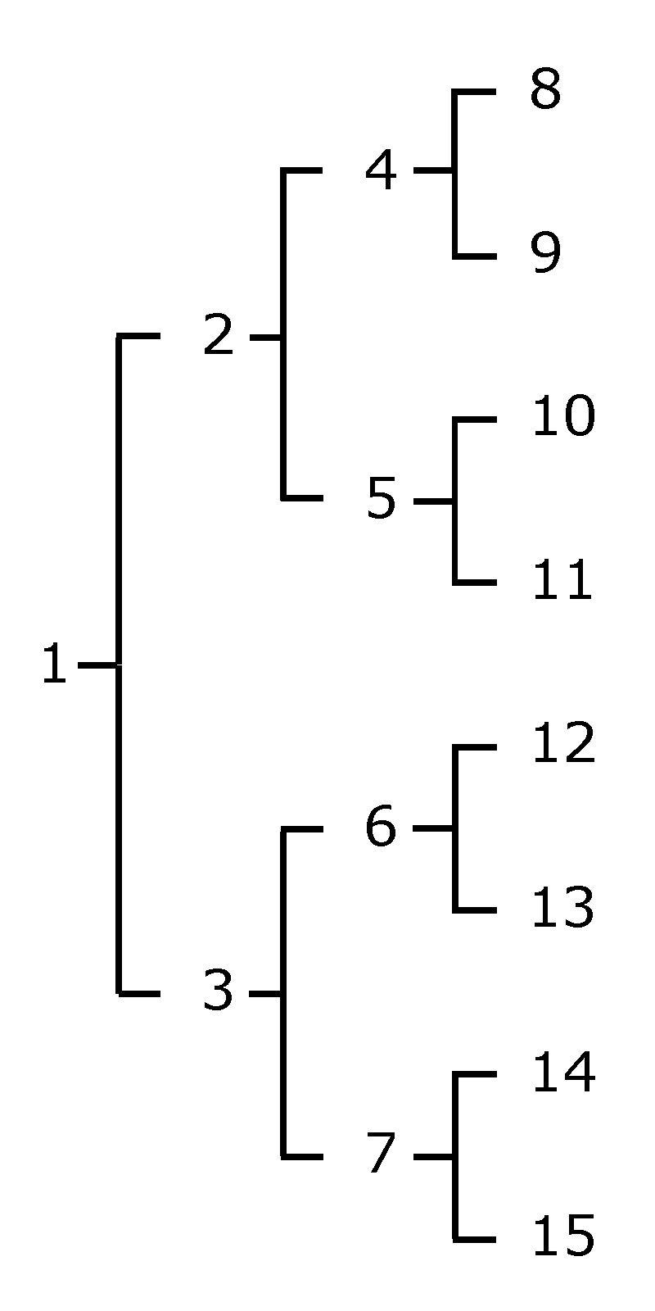

The numbering structure, as illustrated above, follows genealogy convention. The number of the father of each individual is double the individual's number. The number of the mother of each individual equals double the individual's number plus one. Each tree data file will be limited to 6 generations, or 63 persons plus full siblings of the root person (to limit file sizes). Some means of including full siblings in the <tree> data structure is required to reduce data replication. This aspect remains to be resolved in conjunction with navigation method determinations.
Each tree data file can be truncated on any branch by referencing a specific ancestor element to another tree data file wherein that ancestor is found. This provision intends to eliminate, or at least limit, replication. For example, the ancestry of the praternal great-grandfather may be available in another resource location, so the element <8> would have an <info> child element indicating the location of another <tree> data file. Another form of truncation would be an unknown ancestor. Only the first three child elements <1>, <2>, and <3> would be required (parents can be unknown). Only the root element and the first generation children cannot truncate a family tree.
Appendix A. Proposed Personal Data File Code.

<?xml version="1.0" encoding="UTF-8" ?>
<!-- Family GEM Project file →

<data:per xmlns:xsi="http://www.w3.org/2001/XMLSchema-instance"
xmlns:person="http://www.familygem.com/~user/ns"
xsi:schemaLocation="http://www.familygem.com/~user/ns data.xsd">

<id></id>
<tree></tree>
<mem></mem>
<info>
<fn></fn>
<mn></mn>
<sn></sn>
<pn></pn>
<mn></mn>
<syn></syn>
<g></g>
<d></d>
<bd></bd>
<dd></dd>
<rd></rd>
</d>
<geo>
<bp>
<lat></lat>
<long></long>
</bp>
<bl></bl>
<bs></bs>
<bn></bn>
<dp></dp>
</geo>
<src></src>
<img></img>
<img2></img2>
</info>
<afam>
<pm>
<id></id>
<tree></tree>
<mem></mem>
<info>
<fn></fn>
<mn></mn>
<sn></sn>
<pn></pn>
<mn></mn>
<syn></syn>
<g></g>
<d></d>
<bd></bd>
<dd></dd>
<rd></rd>
</d>
<geo>
<bp>
<lat></lat>
<long></long>
</bp>
<bl></bl>
<bs></bs>
<bn></bn>
<dp></dp>
</geo>
<src></src>
<img></img>
<img2></img2>

</info>
<mem></mem>
<mar>
<md></md>
<mp></mp>
<ms></ms>
<mn></mn>
<mem></mem>
</mar>
<s></s>
</pm>
<pf>
<id></id>
<tree></tree>
<mem></mem>
<info>
<fn></fn>
<mn></mn>
<sn></sn>
<pn></pn>
<mn></mn>
<syn></syn>
<g></g>
<d></d>
<bd></bd>
<dd></dd>
<rd></rd>
</d>
<geo>
<bp>
<lat></lat>
<long></long>
</bp>
<bl></bl>
<bs></bs>
<bn></bn>
<dp></dp>
</geo>
<src></src>
<img></img>
<img2></img2>

</info>
<mem></mem>
<mar>
<md></md>
<mp></mp>
<ms></ms>
<mn></mn>
<mem></mem>
</mar>
<s></s>
</pf>
<p1>
<id></id>
<tree></tree>
<mem></mem>
<info>
<fn></fn>
<mn></mn>
<sn></sn>
<pn></pn>
<mn></mn>
<syn></syn>
<g></g>
<d></d>
<bd></bd>
<dd></dd>
<rd></rd>
</d>
<geo>
<bp>
<lat></lat>
<long></long>
</bp>
<bl></bl>
<bs></bs>
<bn></bn>
<dp></dp>
</geo>
<src></src>
<img></img>
<img2></img2>

</info>
<mem></mem>
<mar>
<md></md>
<mp></mp>
<ms></ms>
<mn></mn>
<mem></mem>
</mar>
<s></s>
</p1>
<p2>
<id></id>
<tree></tree>
<mem></mem>
<info>
<fn></fn>
<mn></mn>
<sn></sn>
<pn></pn>
<mn></mn>
<syn></syn>
<g></g>
<d></d>
<bd></bd>
<dd></dd>
<rd></rd>
</d>
<geo>
<bp>
<lat></lat>
<long></long>
</bp>
<bl></bl>
<bs></bs>
<bn></bn>
<dp></dp>
</geo>
<src></src>
<img></img>
<img2></img2>

</info>
<mem></mem>
<mar>
<md></md>
<mp></mp>
<ms></ms>
<mn></mn>
<mem></mem>
</mar>
<s></s>
</p1>
<dfam>
<fm>
<sm>

<mar>
<sf>
<mar>
<s>
<mar>
<dc>
<sc>
<oc>

</data:per>
Appendix B. Proposed Tree Data File Code. Nesting of elements may be modified to follow genetic tree arrangement. Final nesting to be determined with navigation method.

<?xml version="1.0" encoding="UTF-8" ?>
<!-- Family GEM Project file →

<gen:tree xmlns:xsi="http://www.w3.org/2001/XMLSchema-instance"
xmlns:person="http://www.familygem.com/~user/ns"
xsi:schemaLocation="http://www.familygem.com/~user/ns gen.xsd">

<p1>
<person>reference to data file for the root person(s)</person>
<info></info>
</p1>

<p2>
<person>father</person>
<info></info>
</p2>

<p3>
<person>mother</person>
<info></info>
</p3>

<p4>
<person>paternal grandfather</person>
<info></info>
</p4>

<p5>
<person>paternal grandmother</person>
<info></info>
</p5>

<p6>
<person>maternal grandfather</person>
<info></info>
</p6>

<p7>
<person>maternal grandmother</person>
<info></info>
</p7>

<p8>
<person>paternal great-grandfather</person>
<info></info>
</p8>

<p9>
<person></person>
<info></info>
</p9>

<p10>
<person></person>
<info></info>
</p10>

<p11>
<person></person>
<info></info>
</p11>

<p12>
<person></person>
<info></info>
</p12>

<p13>
<person></person>
<info></info>
</p13>

<p14>
<person></person>
<info></info>
</p14>

<p15>
<person></person>
<info></info>
</p15>

<p16>
<person></person>
<info></info>
</p16>

<p17>
<person></person>
<info></info>
</p17>

<p18>
<person></person>
<info></info>
</p18>

<p19>
<person></person>
<info></info>
</p19>

<p20>
<person></person>
<info></info>
</p20>

<p21>
<person></person>
<info></info>
</p21>

<p22>
<person></person>
<info></info>
</p22>

<p23>
<person></person>
<info></info>
</p23>

<p24>
<person></person>
<info></info>
</p24>

<p25>
<person></person>
<info></info>
</p25>

<p26>
<person></person>
<info></info>
</p26>

<p27>
<person></person>
<info></info>
</p27>

<p28>
<person></person>
<info></info>
</p28>

<p29>
<person></person>
<info></info>
</p29>

<p30>
<person></person>
<info></info>
</p30>

<p31>
<person></person>
<info></info>
</p31>

<p32>
<person></person>
<info></info>
</p32>

<p33>
<person></person>
<info></info>
</p33>

<p34>
<person></person>
<info></info>
</p34>

<p35>
<person></person>
<info></info>
</p35>

<p36>
<person></person>
<info></info>
</p36>

<p37>
<person></person>
<info></info>
</p37>

<p38>
<person></person>
<info></info>
</p38>

<p39>
<person></person>
<info></info>
</p39>

<p40>
<person></person>
<info></info>
</p40>

<p41>
<person></person>
<info></info>
</p41>

<p42>
<person></person>
<info></info>
</p42>

<p43>
<person></person>
<info></info>
</p43>

<p44>
<person></person>
<info></info>
</p44>

<p45>
<person></person>
<info></info>
</p45>

<p46>
<person></person>
<info></info>
</p46>

<p47>
<person></person>
<info></info>
</p47>

<p48>
<person></person>
<info></info>
</p48>

<p49>
<person></person>
<info></info>
</p49>

<p50>
<person></person>
<info></info>
</p50>

<p51>
<person></person>
<info></info>
</p51>

<p52>
<person></person>
<info></info>
</p52>

<p53>
<person></person>
<info></info>
</p53>

<p54>
<person></person>
<info></info>
</p54>

<p55>
<person></person>
<info></info>
</p55>

<p56>
<person></person>
<info></info>
</p56>

<p57>
<person></person>
<info></info>
</p57>

<p58>
<person></person>
<info></info>
</p58>

<p59>
<person></person>
<info></info>
</p59>

<p60>
<person></person>
<info></info>
</p60>

<p61>
<person></person>
<info></info>
</p61>

<p62>
<person></person>
<info></info>
</p62>

<p63>
<person></person>
<info></info>
</p63>
</gen:tree>

